|  |  |
| --- | --- |
| Critical Information Summary | |
| Student Name | Alex Ruth |
| SID | 216106075 |
| Mark Aimed For (%) | 80 |

### Criteria: Code Commits [HD]

To meet the HD criteria, I must have:

* At least 25 unique-day commits.

For my project, I made more than 35 unique-day commits and a total of 72 total commits (as of 16th May).

My commits can be found at:

https://github.com/Alexmruth/SIT305ass2/commits/master

### Criteria: Weekly Progress [Distinction/HD]

To meet the distinction/HD criteria, I must have:

* Updated the changelog once a week
* List all new major features added per day-of-work, and what I’m still working on
* Summary of progression related to my milestones.

For my project, I have a changelog.txt file which lists all major features added and what I’m working on, plus a summary of progression related to milestones. Here is an example from my changelog file:

### Criteria: Code Quality [Distinction/HD]

To meet the distinction/HD criteria, I must have:

* Perfect indentation
* Every class and major method/function has an explanation comment
* Examples on where the function is called

For my project, I have perfectly indented and organised code, with the help of the reformate code and auto-indent features in Android Studio. Every class and major method/function have comments which describe and explain what it’s used for and where it is used. Below is an example of my code:

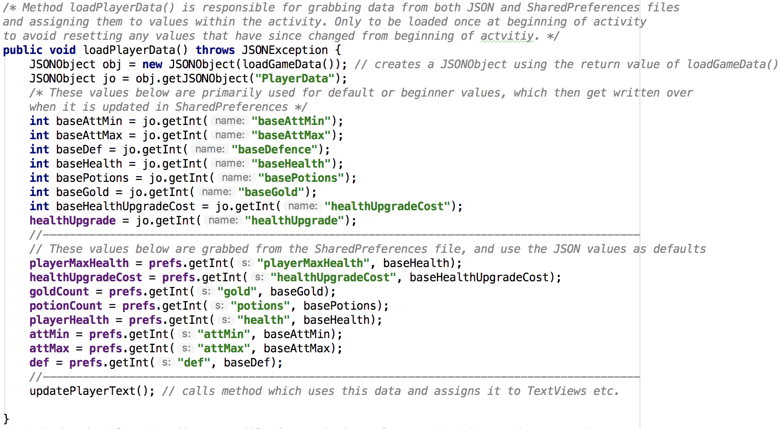

### Criteria: Legal [Distinction/HD]

To achieve the distinction/HD criteria, I must have:

* A licenses.txt file with all material attributed
* A legal/about section in my app with attributions where required
* Attributions include hyperlinks to source pages

For my project, I have included a lisecnes.txt file that is fully comprehensive. I also added an ‘about’ page which can be accessed from the main menu with gives credit to all authors who’s content fell under the Creative Commons CC BY 3.0 licensing. This also included the source URL. The below image is the view of the ‘about’ page:

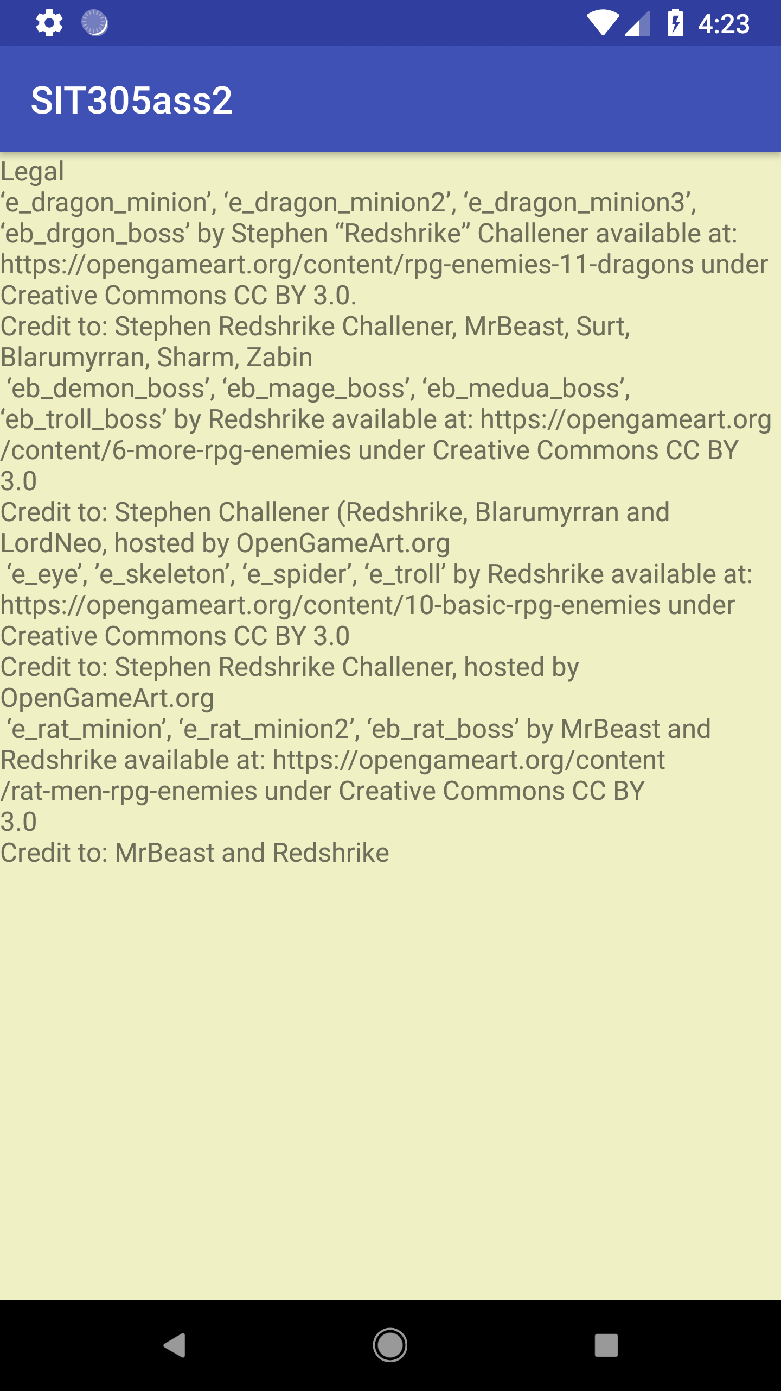

### Criteria: NAME OF CRITERIA [Pass/Credit/Distinction/HD]

(Evidence screenshot and/or bullet-point explanation)

### Criteria: NAME OF CRITERIA [Pass/Credit/Distinction/HD]

(Evidence screenshot and/or bullet-point explanation)

### Criteria: NAME OF CRITERIA [Pass/Credit/Distinction/HD]

(Evidence screenshot and/or bullet-point explanation)